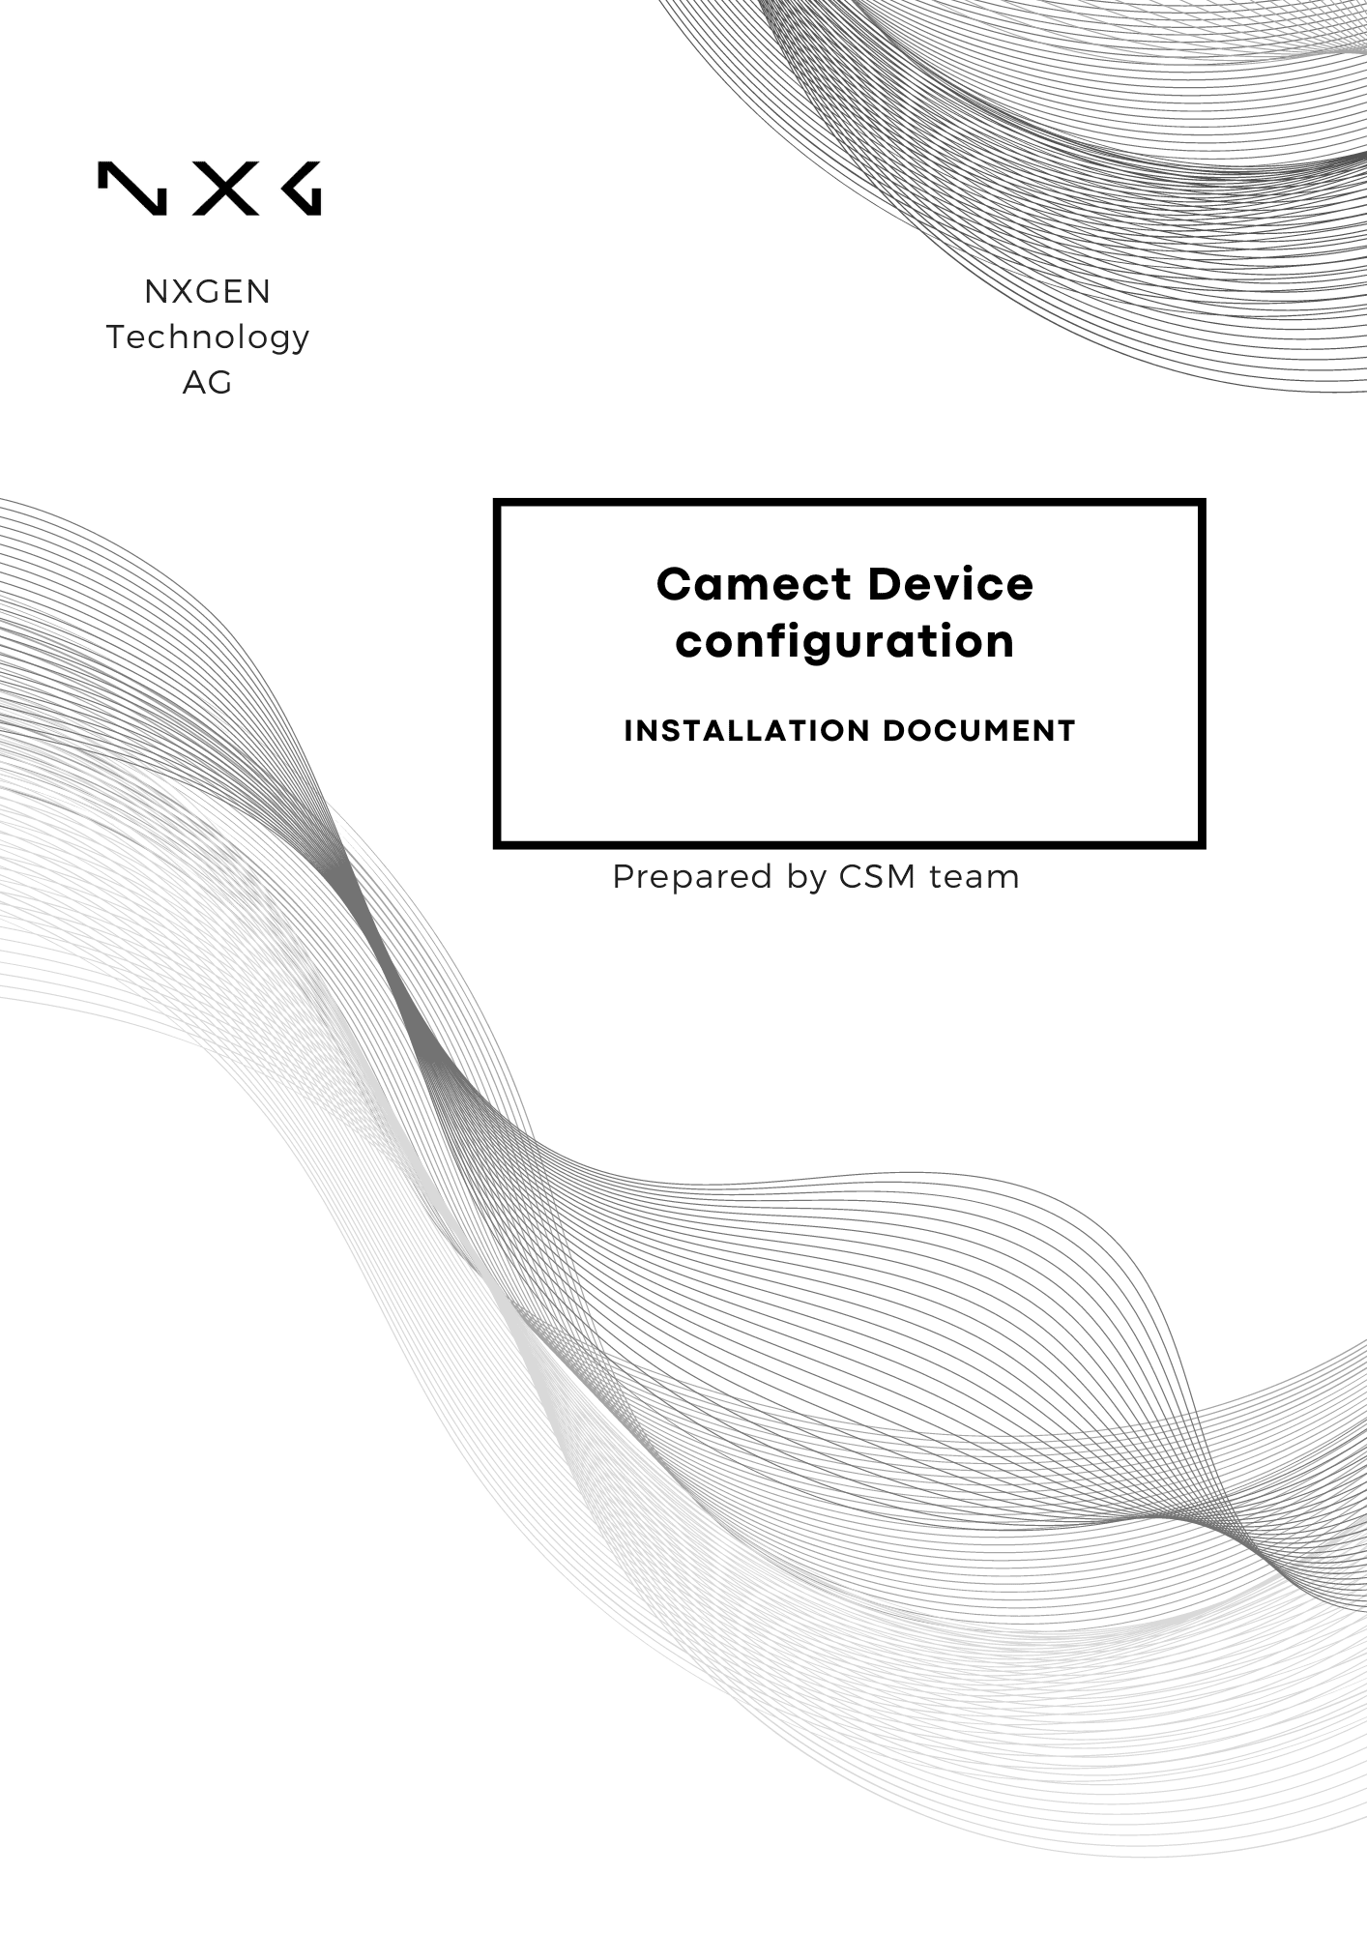

Disclaimer:
Data handling Agreement:
Using NXGEN services implies a commitment to responsibly handle our data and systems. We expect all users to refrain from unauthorized access, misuse, or tampering with NXGEN's data and infrastructure. Any such activity is strictly prohibited and may lead to legal consequences. Your cooperation in maintaining a secure environment is essential for the safety and reliability of our services.

Intellectual Property and Copyright:
All content, including but not limited to text, graphics, logos, images, audio clips, and software, available on NXGEN's platforms and services is the intellectual property of NXGEN or its licensors and is protected by copyright laws. Unauthorized reproduction, distribution, or modification of any content without prior written consent from NXGEN is strictly prohibited. Users are granted limited, non-exclusive, and revocable permission to access and use the content for personal or internal business purposes only. Any misuse or infringement of NXGEN's intellectual property rights will be subject to legal action.

Liability:
You agree to follow the instructions in the User Manual and product documents when installing, setting up, and using the products
Indemnification:
You agree to fully indemnify and hold NXGEN harmless against any claims, costs, demands, or damages (including full legal costs) incurred or that may arise from your use of the products.
https://www.nxgen.io/

Table of Contents
Disclaimer: 2
Introduction: 4
Steps to configure Camect device: 5
Camect Device Configuration Guide with GCX-ONE 13

Introduction:
This report provides a comprehensive guide on configuring Camect devices to work seamlessly with the Genesis platform and Camect device. By following these steps, users can ensure optimal performance and security for their surveillance systems.
and monitoring capabilities.
If any issues arise with the configuration, please raise a ticket on NXGEN's Help-desk portal to the NXGEN support team for swift issue resolution.
Note: For more info please refer to Camect documentation Manual.

Prerequisites:
- Whitelist the IP (CamectReceiver). If you dont use NXGEN OpenVPn services.
- Local Mode is installed in operator workstations.
- Configure the private IP address given by NXGEN in case of using NXGEN OpenVPN services.
- Make sure the RTSP port 554 and the Http port (Control port) 443 are open.

Steps to configure Camect device:
Step 1: Login into your Camect device using the credentials needed.
Step 2: Navigate to the "Hub settings" and ensure the time zone is configured correctly.
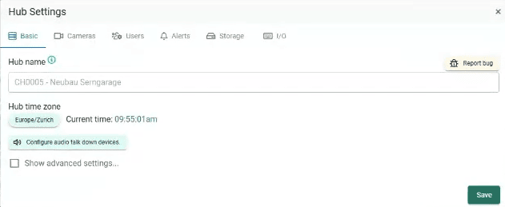

Step 3: On "Hub Settings" Navigate to "Cameras" and make sure the RTSP is enabled.
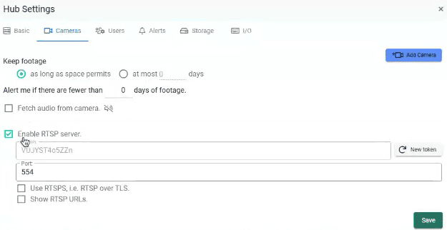
Step 4: Set-up a user for NXGEN (Local User credentials) with the permissions mentioned below:
- Live view.
- Query Cameras.
- Pan/Tilt Cameras.
- View alerts.
- View footage.
- Share cameras.
- Change operating modes.
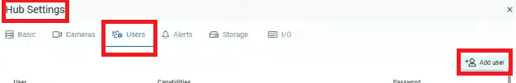

Step 5: On "Camera Settings" navigate to "Basic" and make sure to enable "Pan/Tilt" or "Zoom" if the camera supports this functionality.
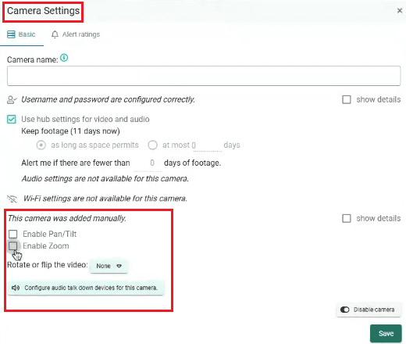
Don't forget to save the changes.
Step 6: If the camera supports "Alerts Rating" configuration, please follow these steps to set it up:
- Click on "Add Ratings".
- Choose "Thumbs down" if you dont want certain objects to trigger an alarm. For Example: bicycle, car, person etc.
- Choose "Thumbs up"if you want to trigger some certain options, such as: Amazon person, DHL person etc.
- Click on "Edit Area" to Specify your area of interest.
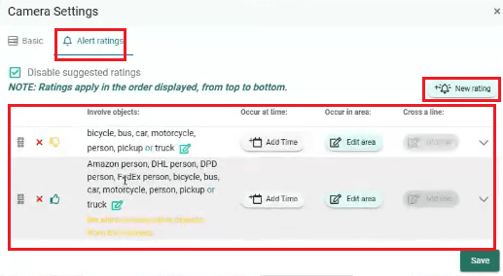
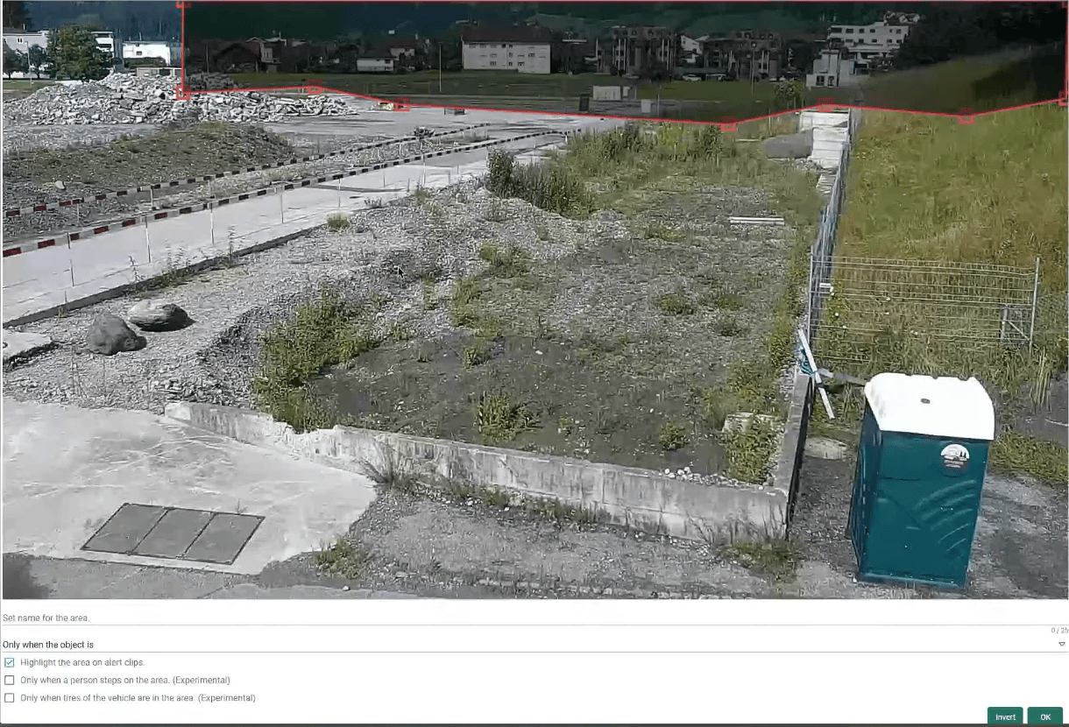

Don't forget to save the changes.
Step 6: Click on "Hub Settings," then navigate to "Alert" to configure alarms at the device level.
- Make sure the "Detect alerts" box is enabled.
- Configure the objects that you want to get it detected under the "Detect objects in alerts".
- Select the alerts needed on your side. Please refer to Camect document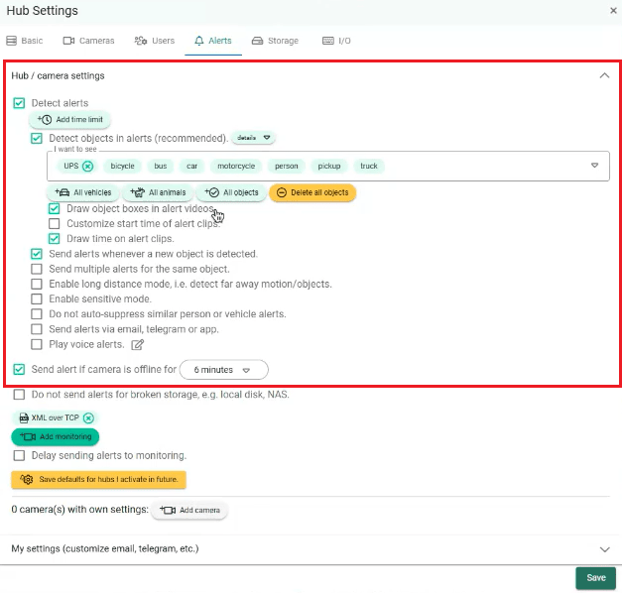
Step 7: In the same window, click on "Add Monitoring" to add a monitoring site.
- Choose "NXGEN" as a monitoring site.
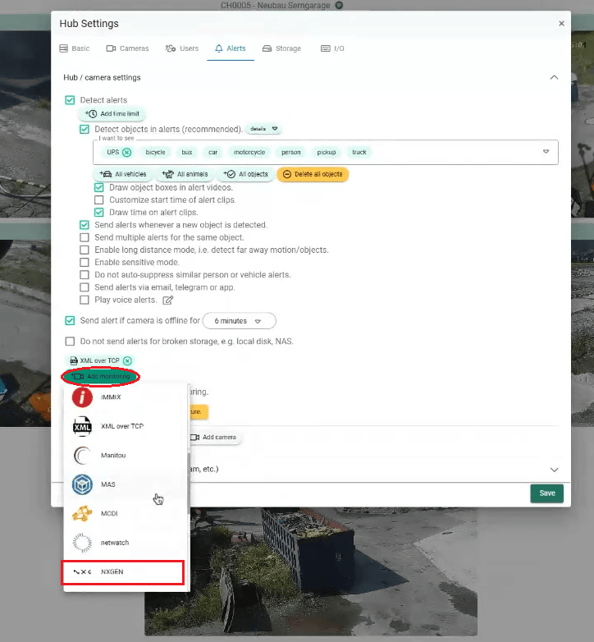

- In Case if NXGEN is not there, choose "IMMIX".
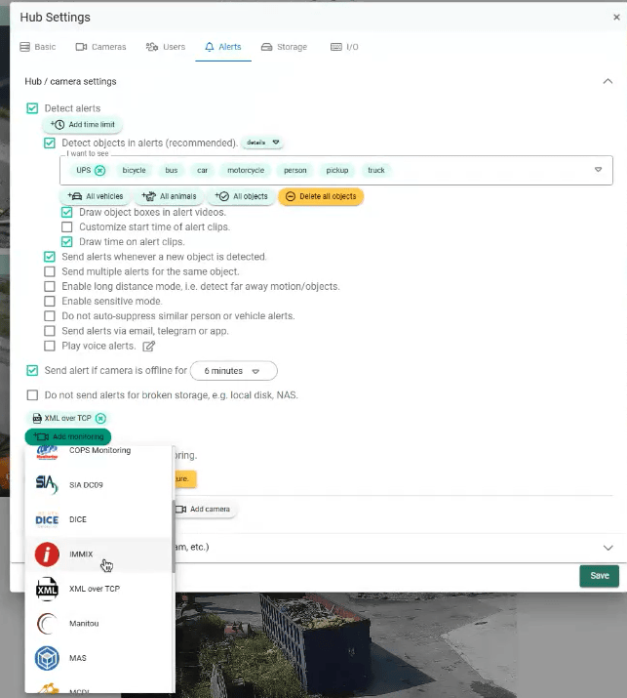
- If you couldn't find both, choose "XML over TCP".

Step 8: When you select NXGEN as a monitoring site, you will be directed to the configuration page. On this page, follow these steps:
- Set the site ID to "1", as a dummy value.
- On TCP address, add Genesis TCP address.
TCP address
TCP address in case of using OpenVPN
- Then click on "Add camera" that has to forward alarms to Genesis.
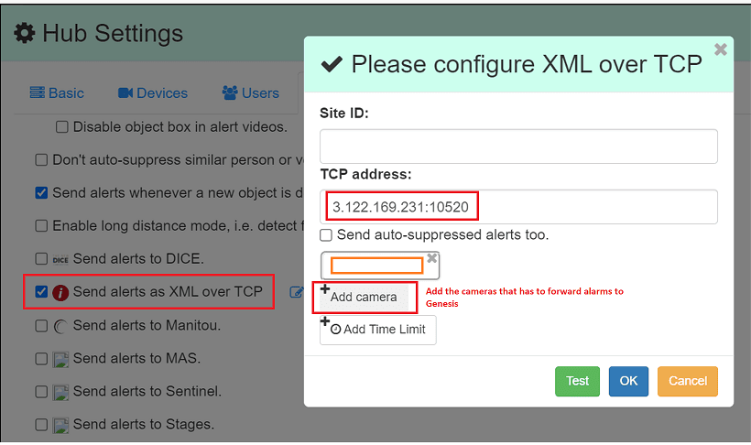
These steps and explanations will help you configure the appropriate analytics on your Camect Device to enhance your security system’s effectiveness and responsiveness.

Camect Device Configuration Guide with GCX-ONE

This document describes the steps required to configure an Camect device in GCX-ONE.

Step 1: Log in to GCX-ONE.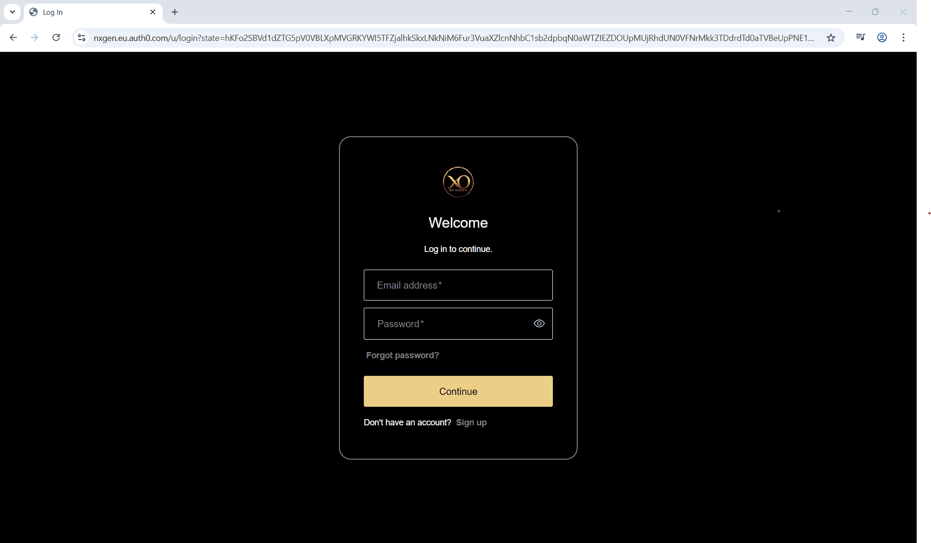

Step 2: Click on the Configuration menu.

Step 3: At the Service Provider level, click on Customers.

Step 4: Click the Add button.

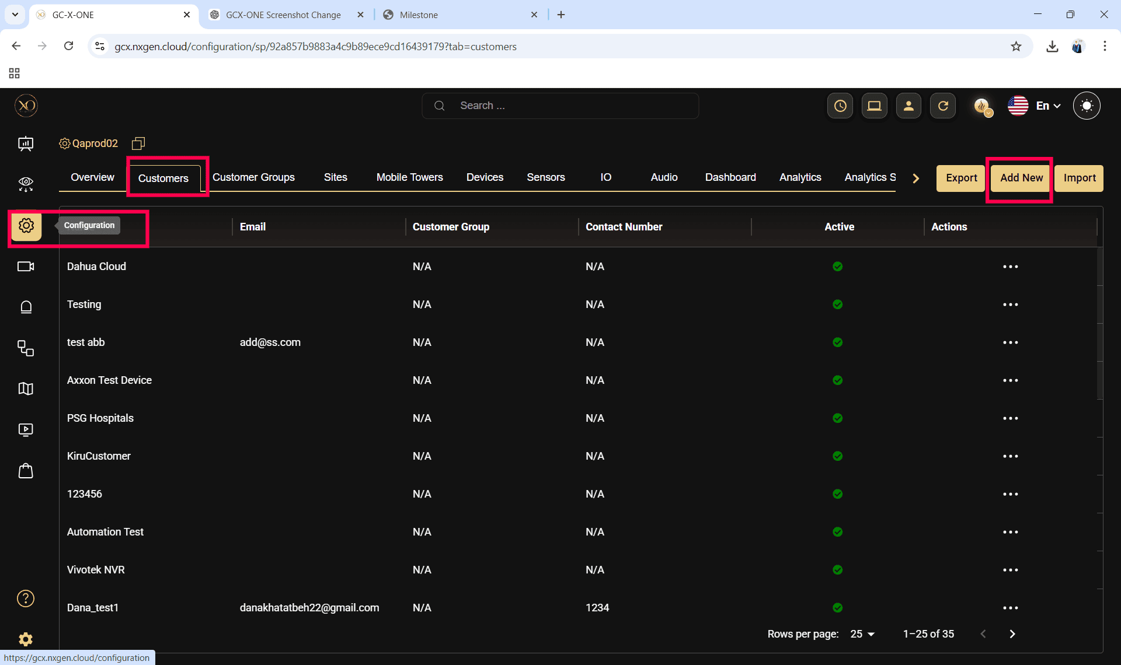

Step 5: Enter the required fields and click Save.

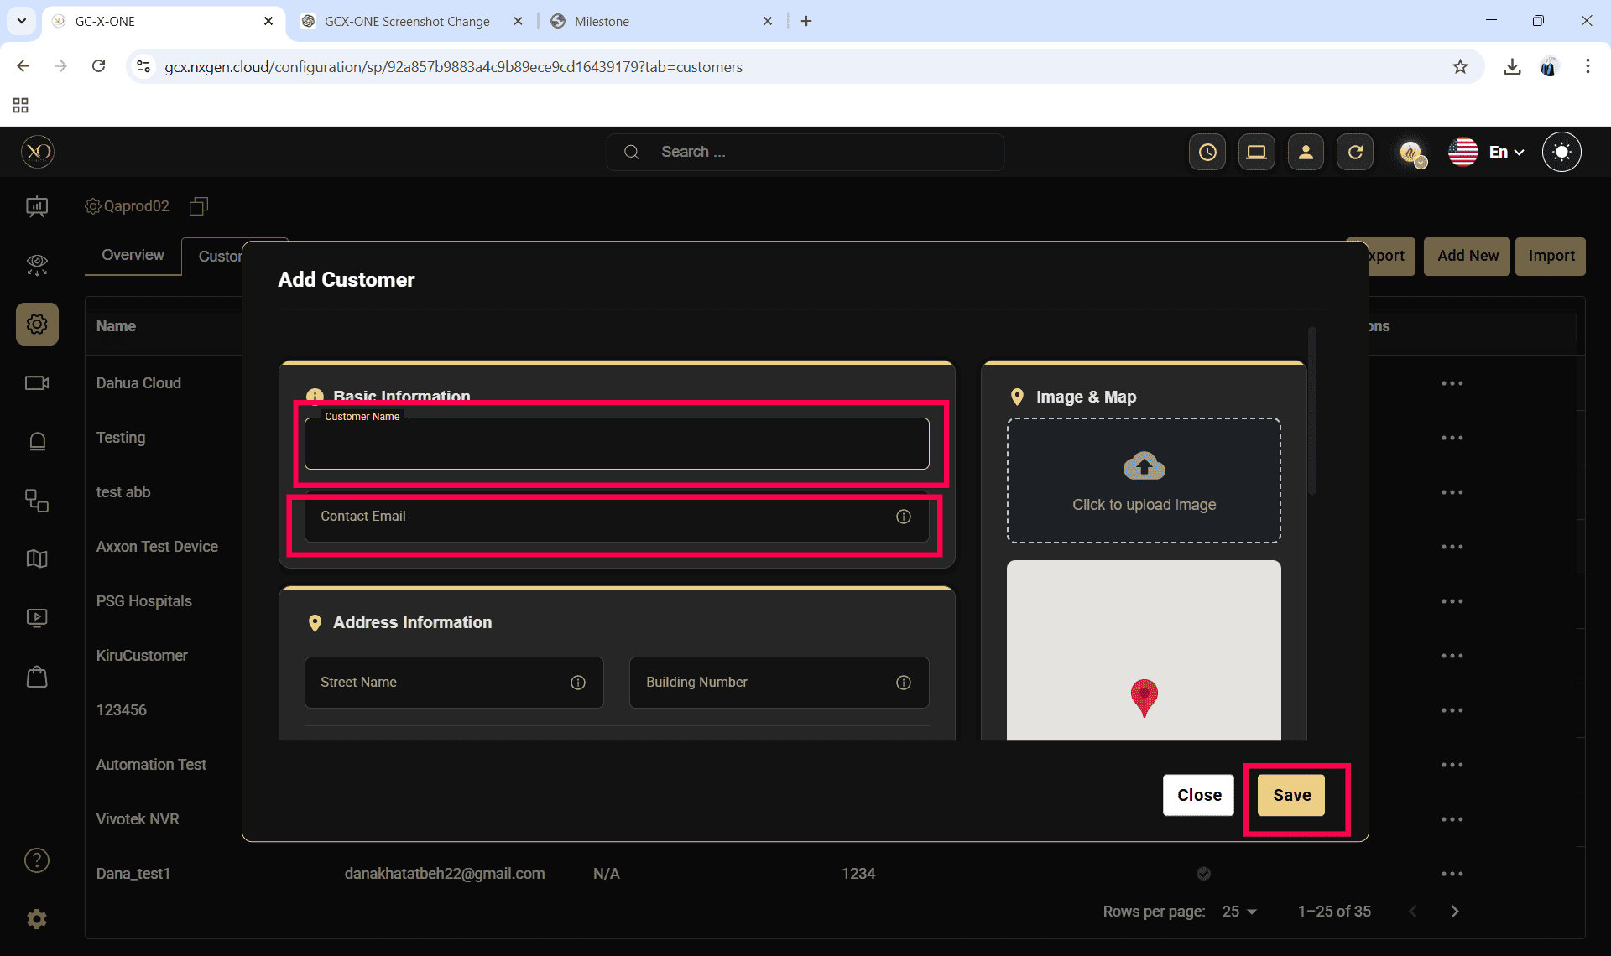

Step 6: Select the newly created customer.

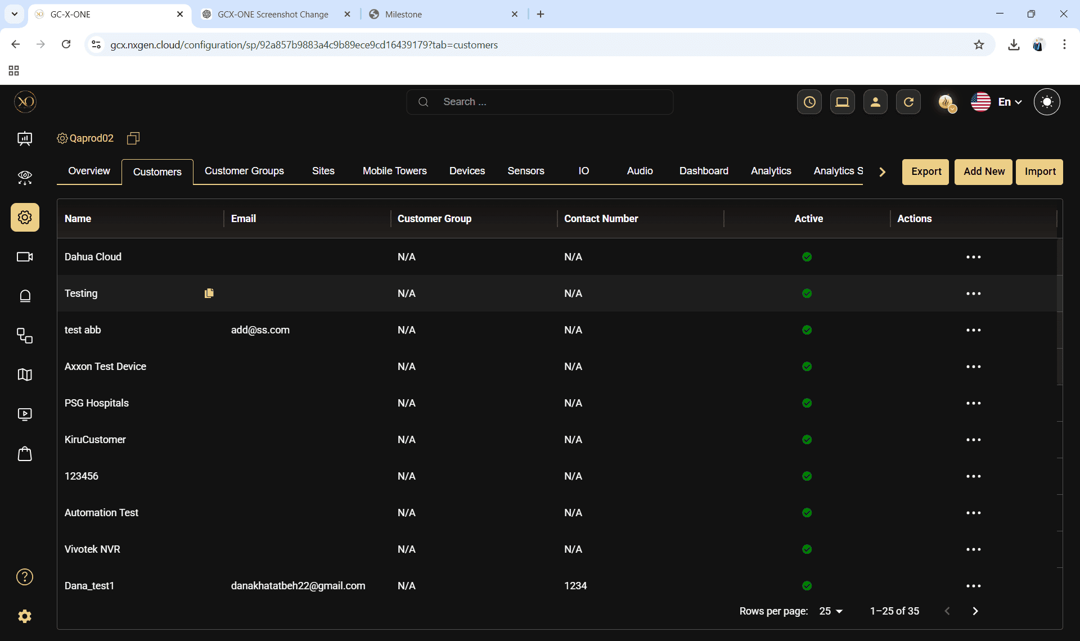

Step 7: Navigate to the Sites tab.

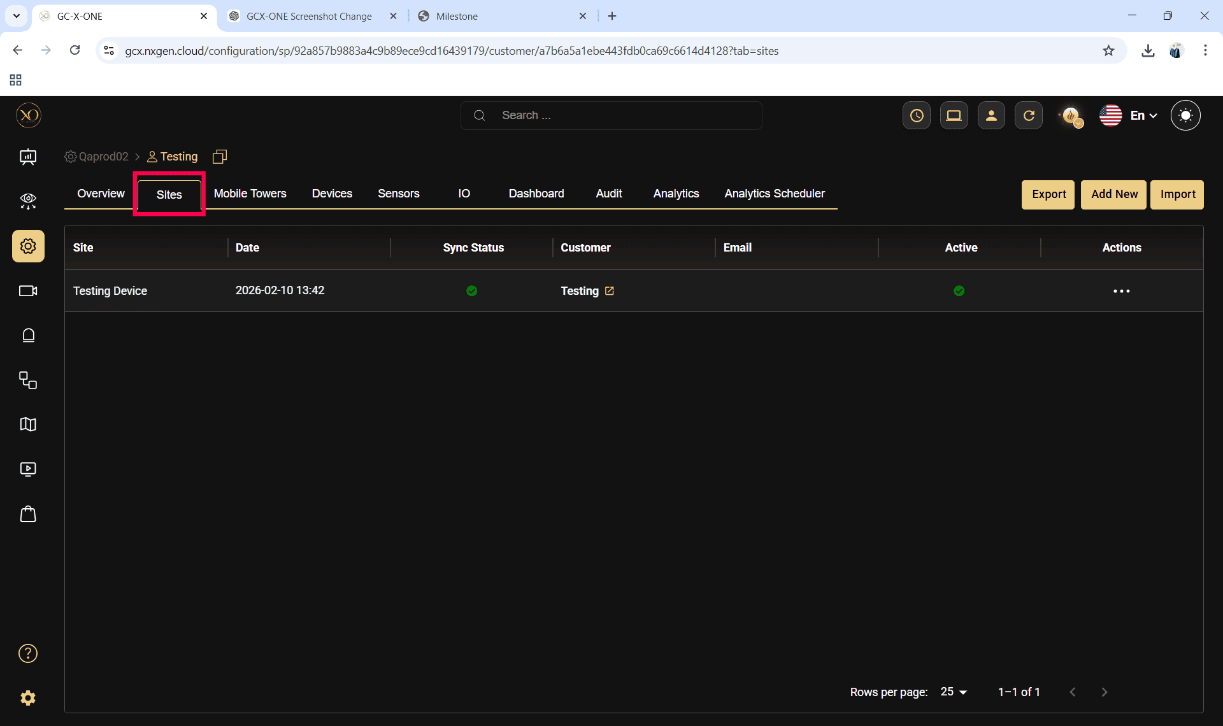

Step 8: Click the Add button.

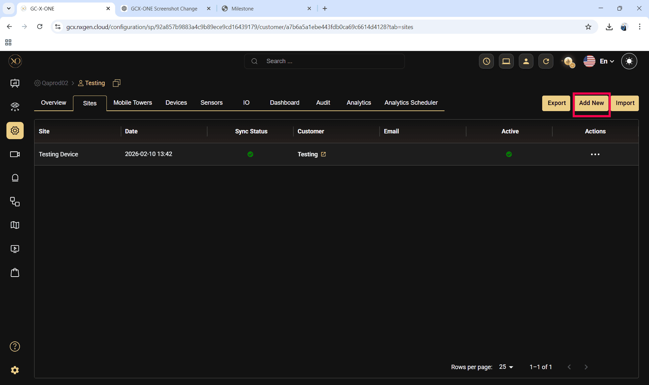

Step 9: Enter the required fields and click Save.

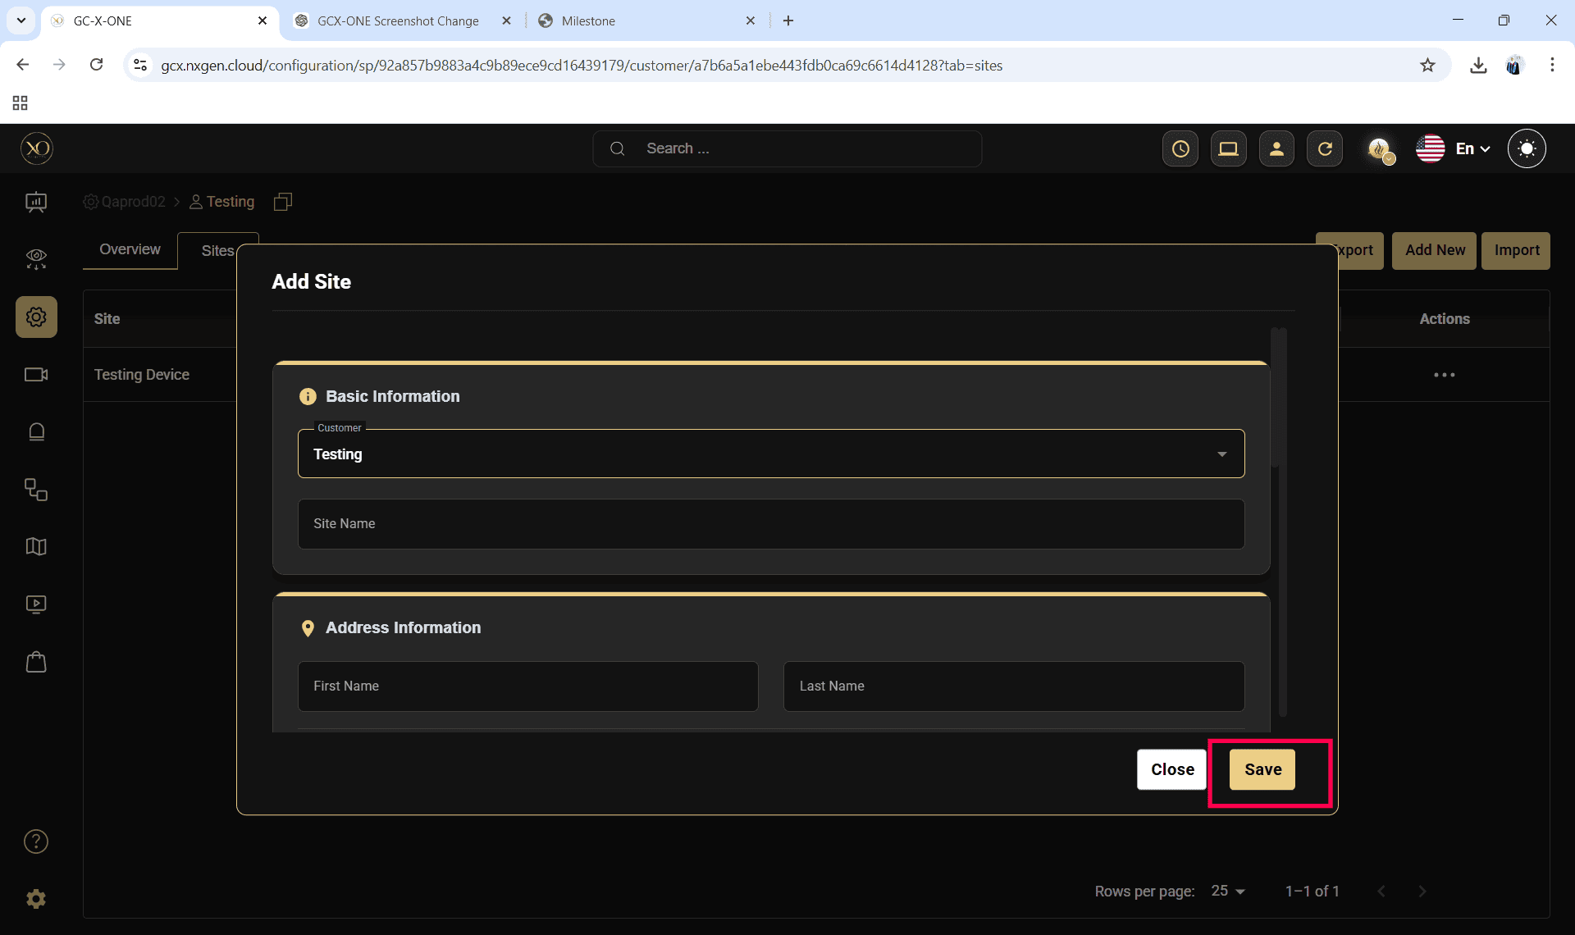

Step 10: Select the newly created site.

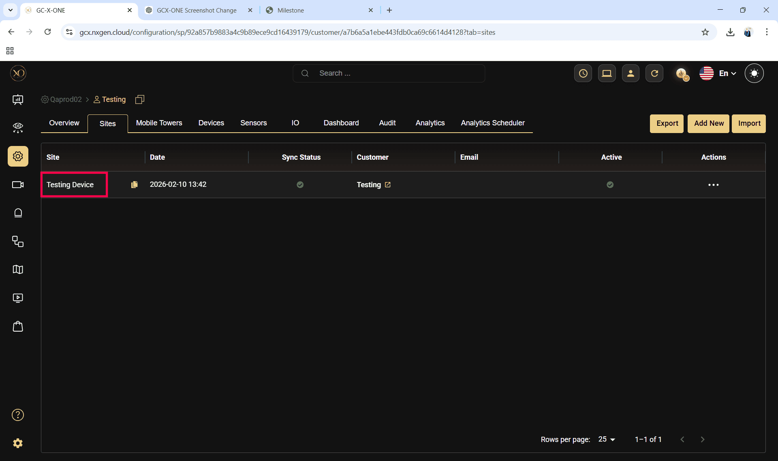

Step 11: Navigate to the Devices tab.

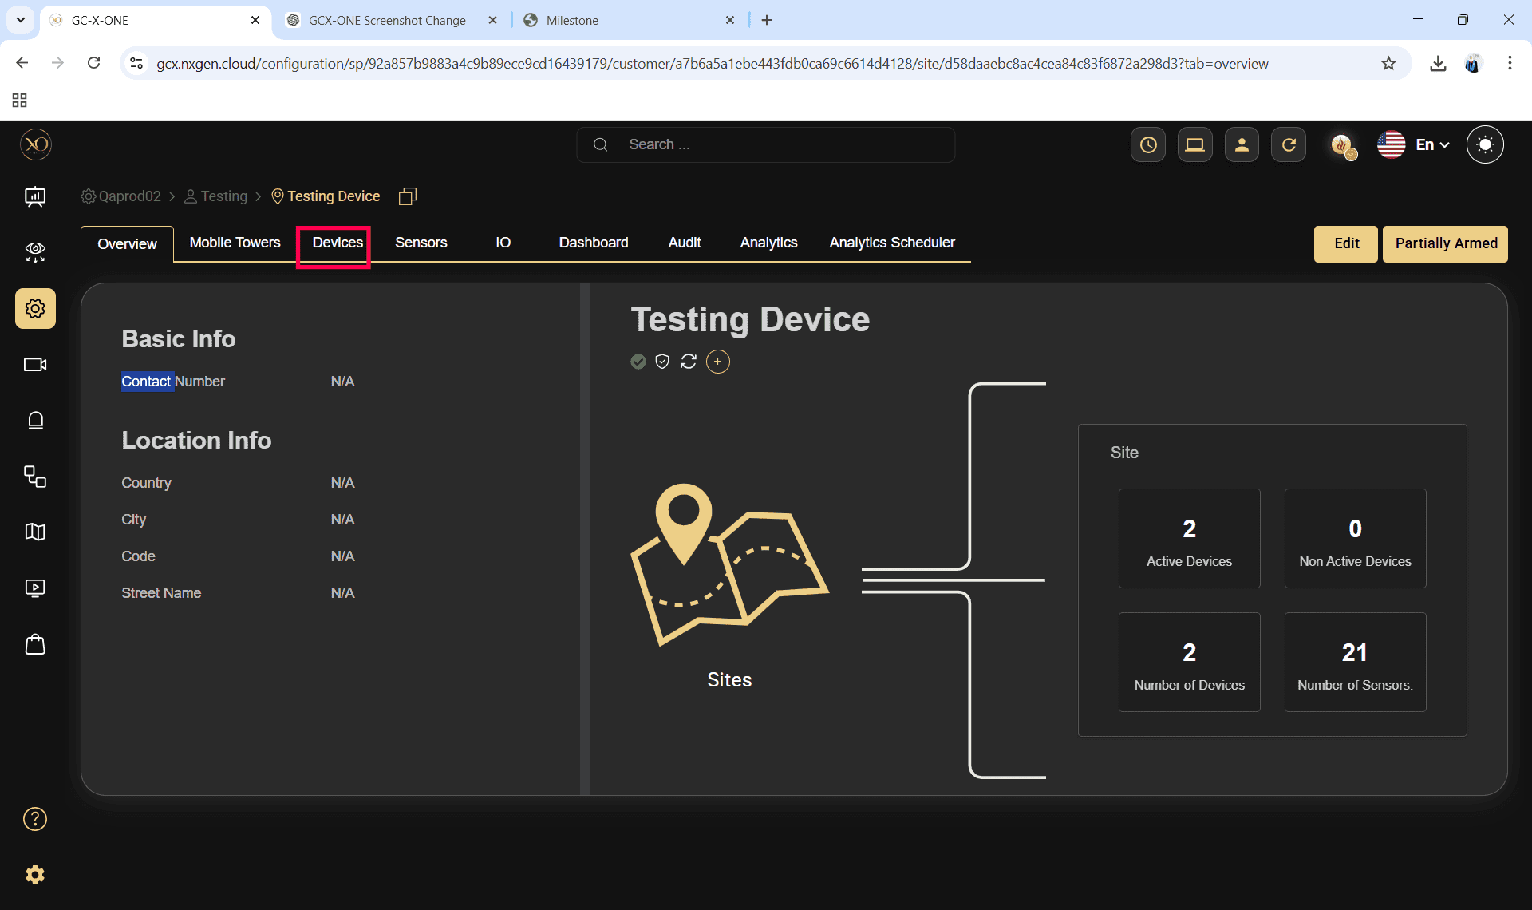

Step 12: Click the Add button.

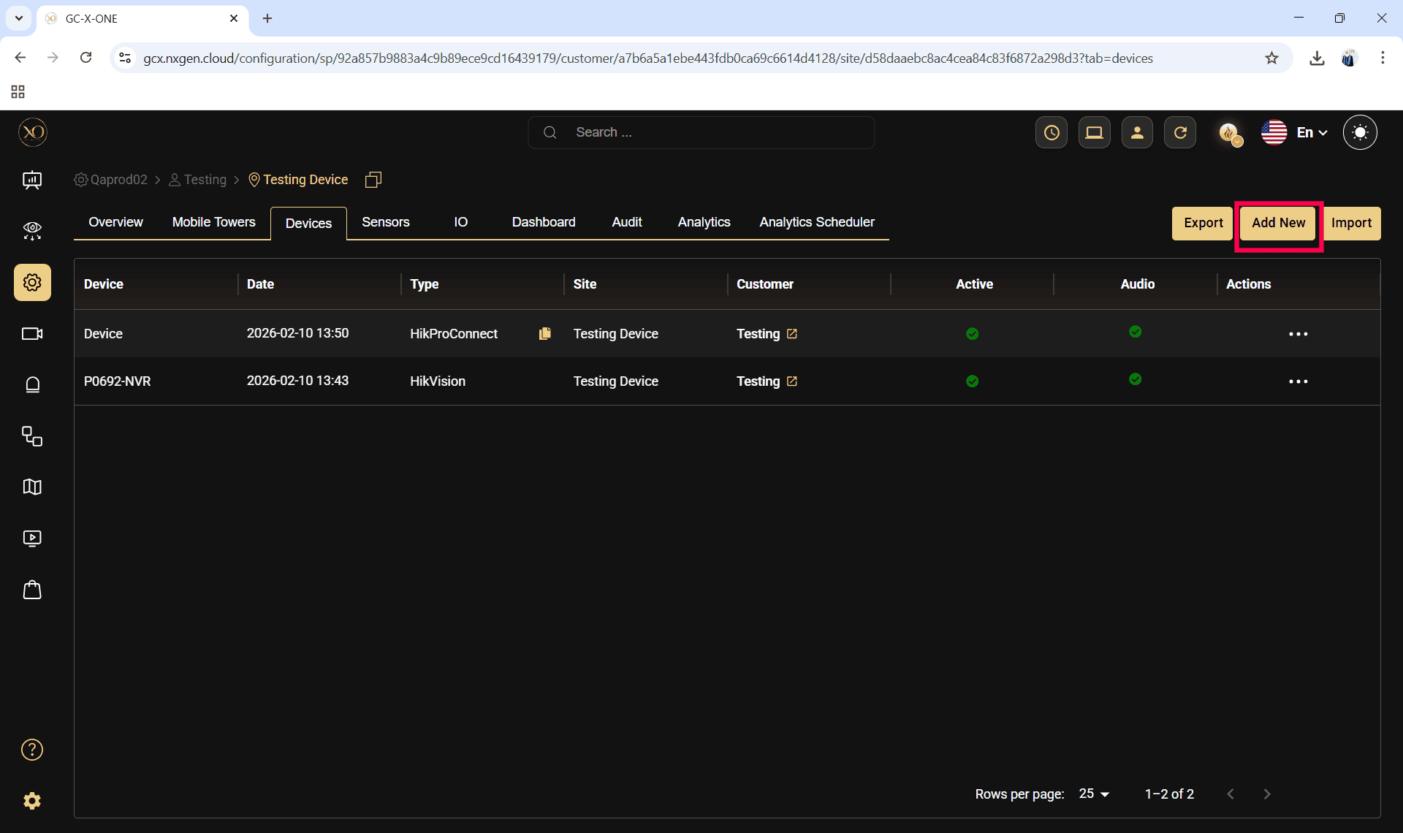

Step 13: The Add Device dialog will be displayed.

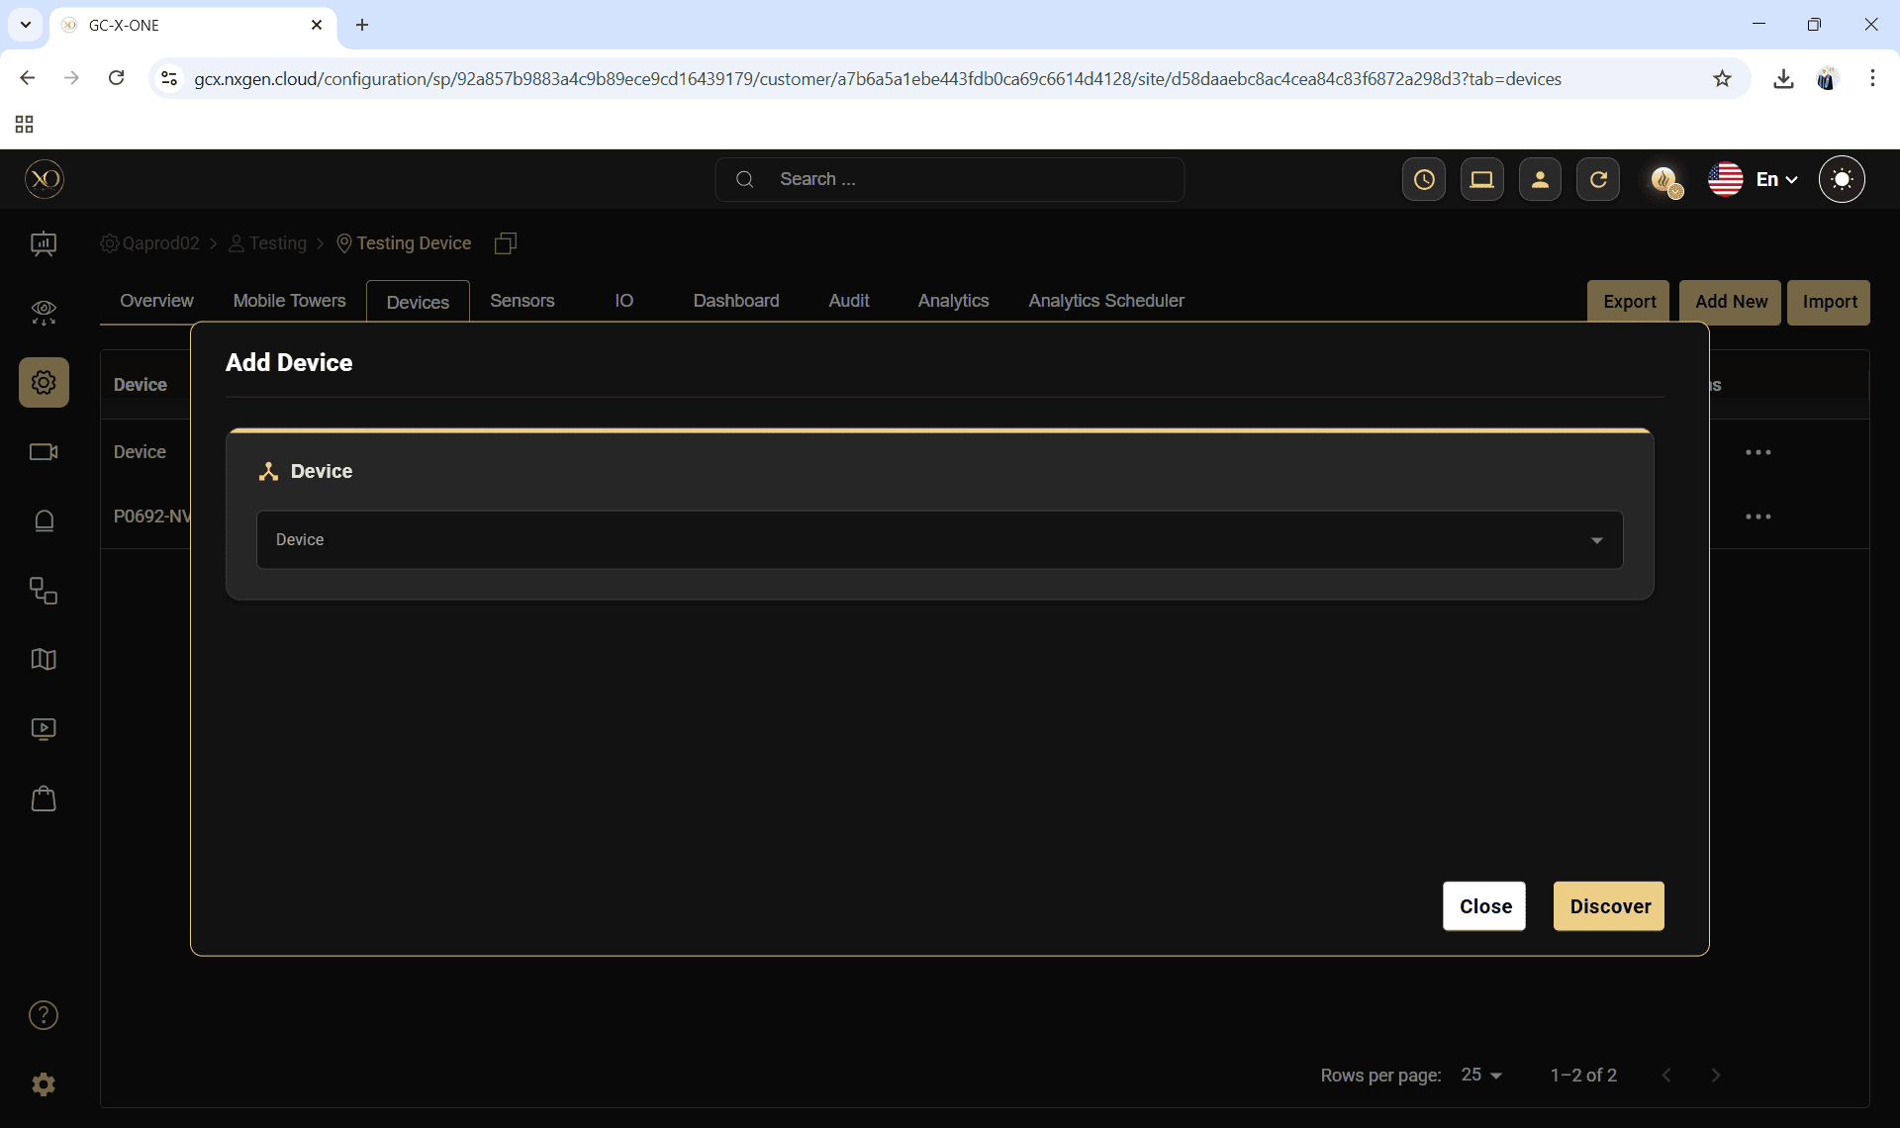

Step 14: In the dialog, open the Device dropdown and select Camect.

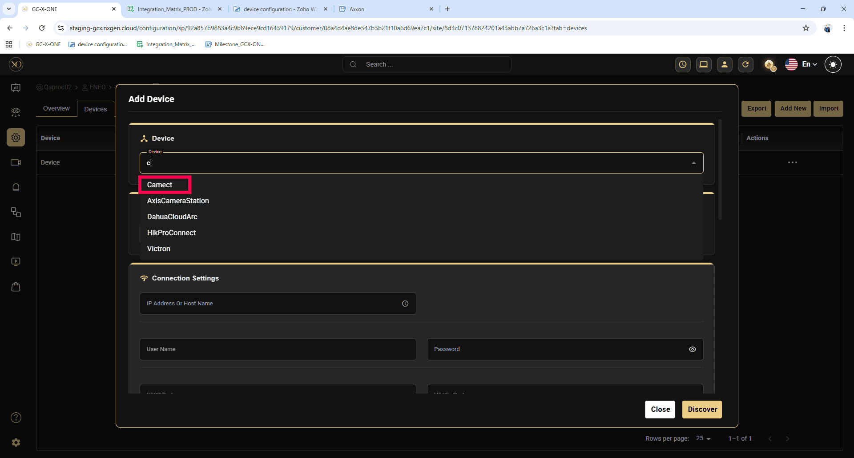

Step 15: Enter all required fields:

Name

IP Address or Host Name

serial number

Username

Password

Control Port

RTSP Port

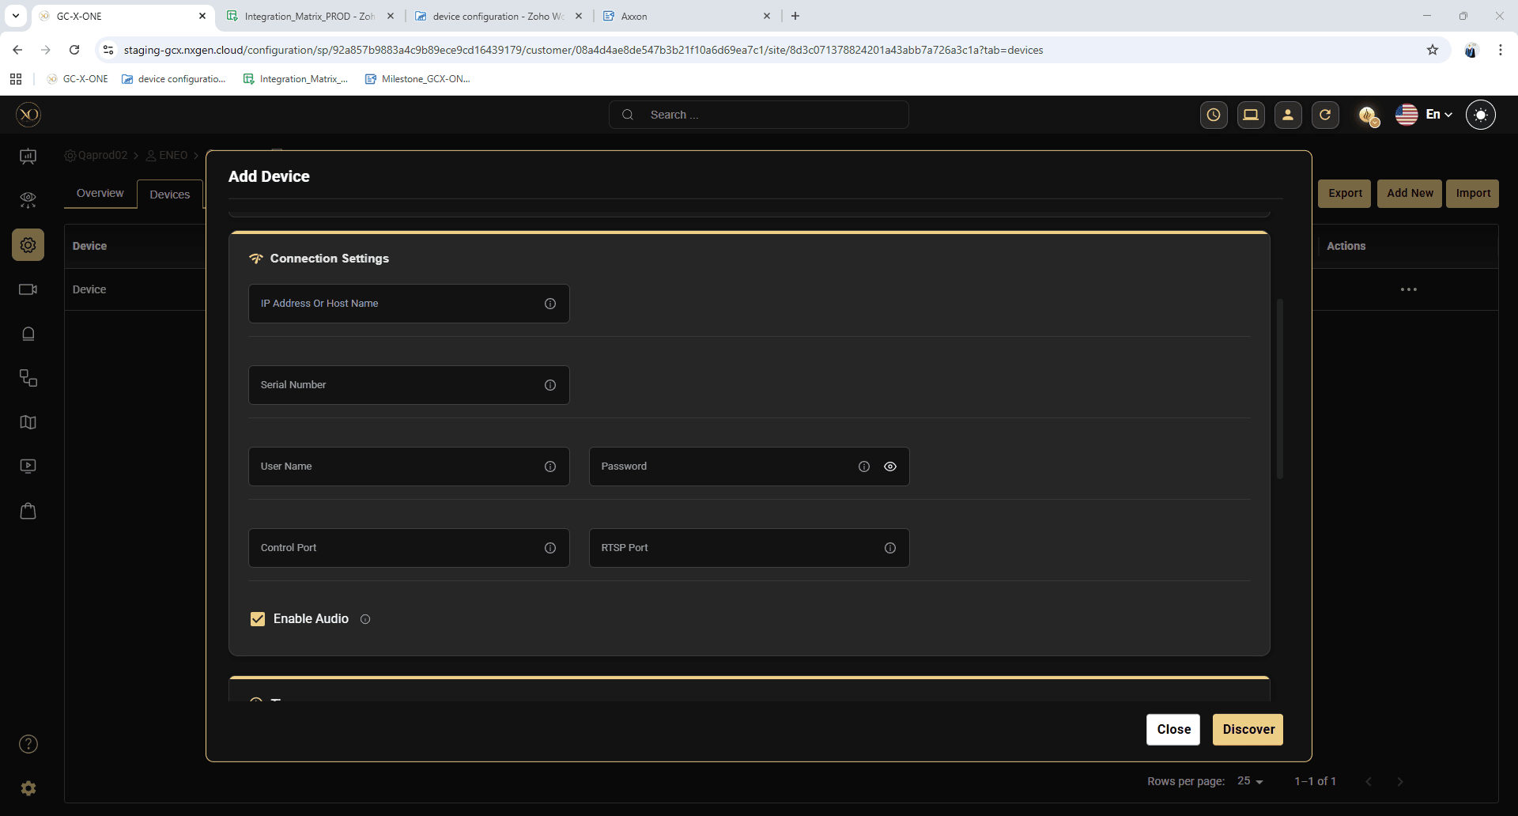

Step 16: Click Discover

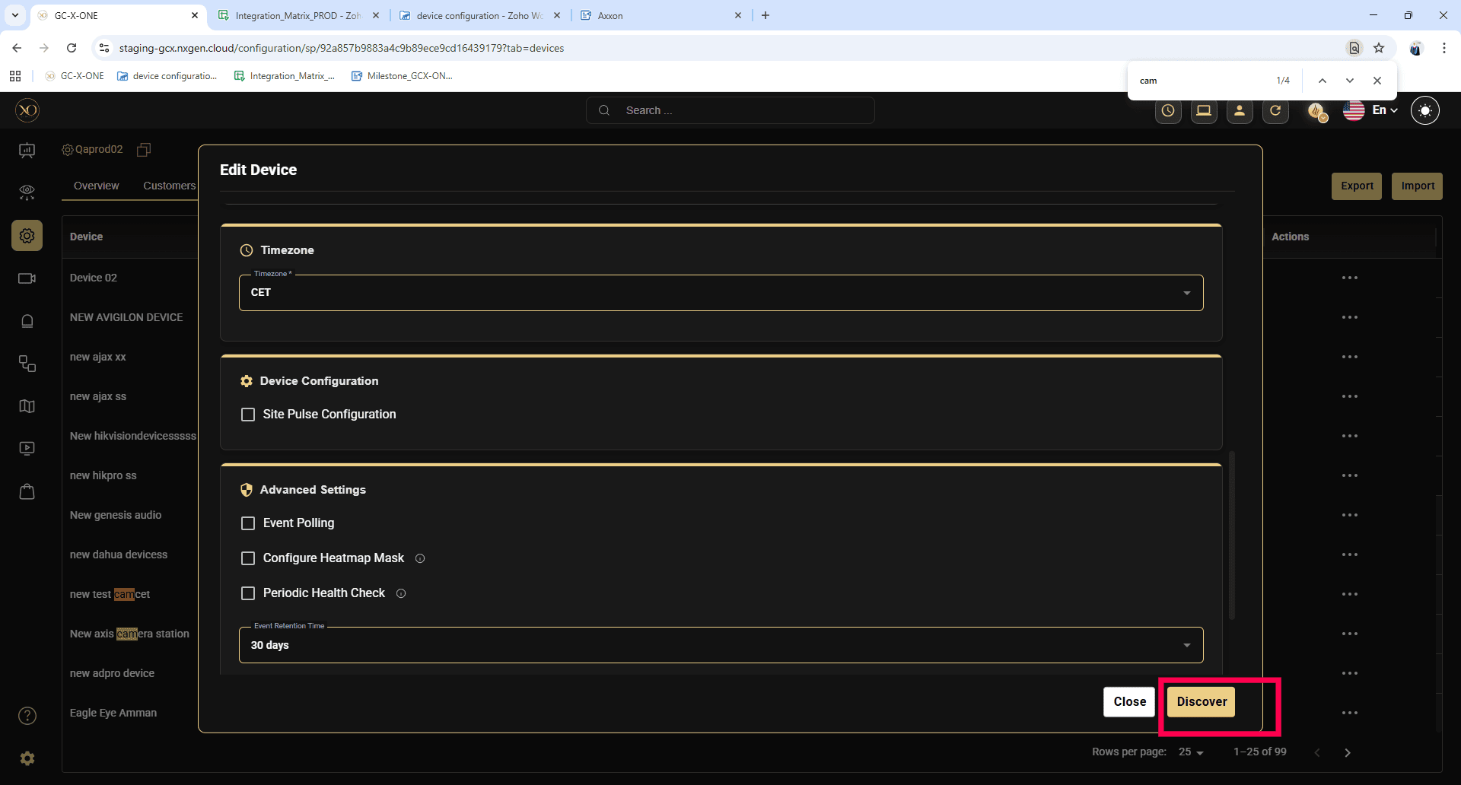

Step 17: Once the device is successfully discovered, click Save.

